**NAME**:Momna Khurram Qureshi

**Sap_id:**55430

**Lab Instructor:**Nayab Khalid Kayani

**TASK 1**

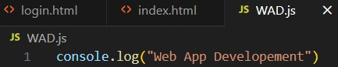

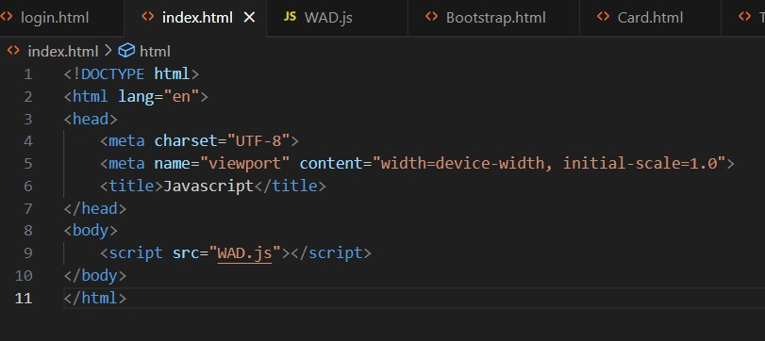

**OUTPUT**

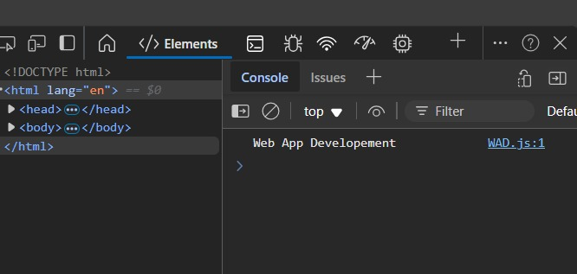

**TASK2**

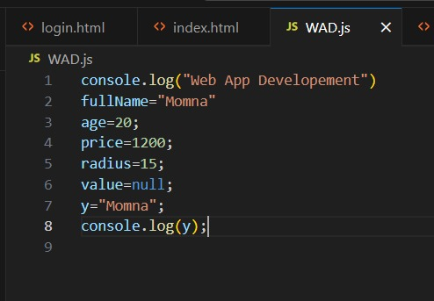

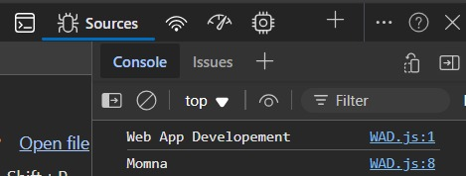**OUTPUT**

**TASK3**